**7117IBA Applied Case Study**

**1. Descriptive Analysis**

Answer 1: Result of money spent per week:

|  |  |  |
| --- | --- | --- |
| **Year** | **Week** | **Total Spend** |
| 2006 | 07 | $13,797.83 |
| 2006 | 09 | $14,785.95 |
| 2006 | 12 | $14,341.26 |
| 2006 | 19 | $14,652.97 |

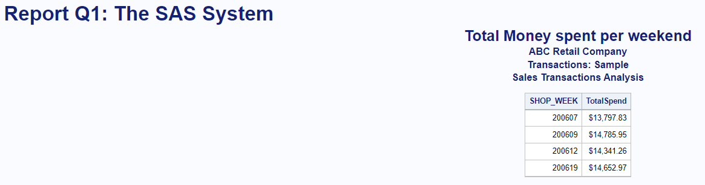

The final amount of money being spent each week fluctuates. The lowest amount of money spent in Week 7 was $3745.53. In addition, $4276.05. was spent in Week nine. Finally, the largest stated value is $4419.37 for Week 12, followed by $4267.80 for Week nineteen. The data suggests that the month of March has the biggest product sales.

Weekly sales data collecting allows for independent decision at all levels of management. Presenting is a significant tool for evaluating the sales team's performance on a weekly basis. Furthermore, data on weekly sales amount spent makes forecasting trends and bottlenecks easier. Understanding the differences in good sales in a given weekly would therefore aid in the efficient allocation of people and other resources.

People spent the greatest sum in the period of March during Week Nine and Week Nineteen which gives a chance to expand sales initiatives in order to increase sales volume. Additionally, the significantly lower number of sales weeks must be tracked in order to identify the factors that contribute to this. Nonetheless, because Weeks 7 and 9 aren't overly stretched, launching a good marketing strategy could result in increased sales.

Answer 2: Result

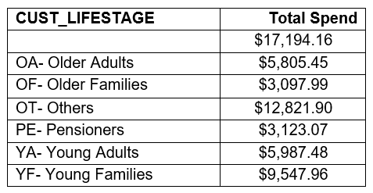

We can learn a lot about our present and potential consumers by segmenting them based on their age and the amount of money they spend. The Older Adults spent $5,805.45 followed by Young Adults at roughly comparable expenditure of $5,987.48. The most minimal spending age section was Older Families $3097.99 alongside Pensioners at $3,123.07. The most noteworthy spenders were Young Families at $9,547.96. The others provide the most, at $12,821.90, which is most noteworthy of the all-out spending of $17,194.16.

Age division is the most essential segment division as it is a device to construct a solid comprehension of shoppers and their way of behaving as for their age. Acquiring Insights from customer orientation according to the age determinant empowers the salesforce to focus on their drives in the correct course and movement, Age division is vital element of customer orientation and sales evaluation.

It is clear from the statistics that our present customers are Young Families and Others, which improves the targeting of marketing campaigns to them in order to increase sales conversions. Furthermore, because Older Adults and Young Adults are our next greatest consumer category, customer orientation is required. Getting a better understanding of their behaviour and other contributing factors can help them get to the bottom of the sales funnel faster.

Answer 3:

|  |  |  |  |  |
| --- | --- | --- | --- | --- |
| **PROD_CODE** | **Total Quantity** | **Total Spend** | **STORE_STATE** | **State Name** |
| PRD0903052 | 234 | $170.40 | NSW | New South Wales |
| PRD0904358 | 233 | $358.82 | NSW | New South Wales |
| PRD0900121 | 200 | $196.00 | NSW | New South Wales |
| PRD0904358 | 183 | $281.82 | VIC | Victoria |
| PRD0903052 | 142 | $118.04 | VIC | Victoria |
| PRD0900121 | 124 | $121.52 | VIC | Victoria |
| PRD0903269 | 112 | $101.92 | NSW | New South Wales |
| PRD0903078 | 109 | $38.15 | VIC | Victoria |
| PRD0901265 | 92 | $154.98 | NSW | New South Wales |
| PRD0901819 | 87 | $35.67 | NSW | New South Wales |
| PRD0903078 | 86 | $30.10 | NSW | New South Wales |
| PRD0903052 | 85 | $70.69 | SA | South Australia |
| PRD0900830 | 78 | $75.66 | NSW | New South Wales |
| PRD0903052 | 75 | $57.57 | WA | West Australia |
| PRD0904887 | 72 | $73.44 | NSW | New South Wales |
| PRD0904358 | 70 | $107.80 | SA | South Australia |
| PRD0901015 | 68 | $104.72 | NSW | New South Wales |
| PRD0904358 | 68 | $104.72 | QLD | Queensland |
| PRD0903052 | 62 | $40.78 | QLD | Queensland |
| PRD0904358 | 61 | $93.94 | WA | West Australia |
| PRD0900302 | 59 | $73.32 | NSW | New South Wales |
| PRD0900947 | 58 | $69.02 | NSW | New South Wales |
| PRD0900121 | 57 | $55.86 | SA | South Australia |
| PRD0903511 | 57 | $193.23 | NSW | New South Wales |
| PRD0900830 | 55 | $53.35 | VIC | Victoria |

The above analysis aids in the computation quantity and total sales of all products by state. Only the top 25 of the quantities sold and total sales for the product in accordance with states are shown in the result above. In addition, it shows that New South Wales had the highest percentage of sales of the top 25 products when compared to the rest. But the comprehensive analysis shows that 5913 goods were only sold once." (SAS output).

The geographic division based on area obviously demonstrates that NSW is the most well-known among the customers with greatest number of sales, most extreme sum spent and the biggest volumes sold as well. Moreover, Victoria and South Australia have decent measure of money spent and the amount sold. Nonetheless, Western Australia and Queensland appear to be disliked among the clients as they have most minimal amount sold and sum spent.

Users from different parts of the country or states have different demands and desires. This segmentation broadens the possibilities for extending the firm in other areas. It also allows the company to better allocate resources and eliminate any unnecessary costs.

A large portion of today's advertising efforts are carried out online prior to traditional execution. These campaigns should be targeted at the correct interest group in order to save expenses and increase transaction yield. Furthermore, determining where the most relevant or probable interest group is located gives the firm an advantage in terms of improving their methodology and innovations.

Answer 4:

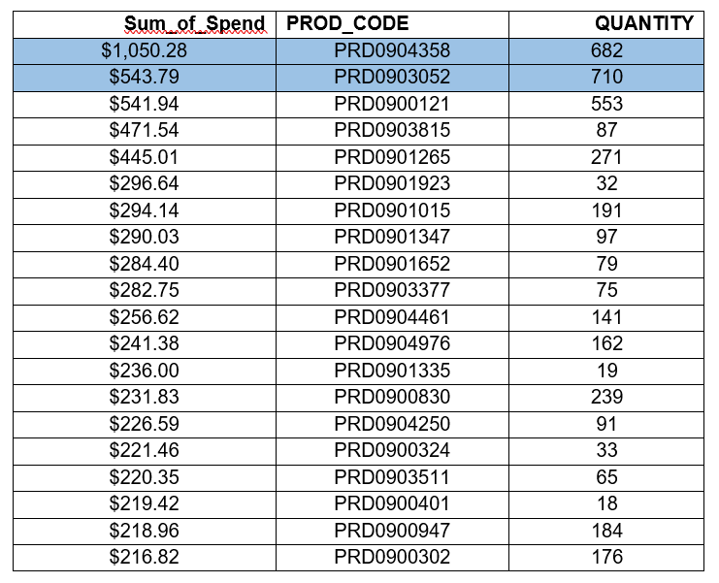

There are two products i.e., PRD0903052 and PRD0904358 were the most popular products among all, with the largest total value, the biggest number of units sold. Also noted that, both products are available in all 50 states. The above result shows or displayed only the top 20 (not all products) that sold where quantity is greater than 1.

The information of the data for the most offered products is significant in terms of spend associated to the items bought which validates the demand and growth for certain products. It is crucial for the sales department to analyse the trend of product’s sales based on the user's needs and wants, as well as which product best meets those demands.

The corporation should concentrate on pushing products that are in great demand across the country, such as PRD0904358 and PRD0903052, and lowering prices for the less sold product. Furthermore, the organisation should strengthen their sales process in order to increase customer base by supplying products that meet consumer requirements and aspirations.

Answer 5:

|  |  |
| --- | --- |
| **Unique_Customers** | **Store_Region** |
| 1857 | W01 |

There are several different products, but according to the requirement, the distinct region where store belongs to W01 and the count of unique customers (customer code) is 1857.

Answer 6:

* For most firms, the creative Insight- Sales Report is one of the most useful navigational assistances. Weekly sales help us comprehend the instant responses and causes affecting the business, whilst yearly and monthly statistics show us a more specific behaviour and react of the customer.
* It refers to segmenting audiences based on observed variations in persons or customer. Age segmentation is the best way to focusing the age range which is most valuable to company’s product or service. According to this best technique, we can confidently state that the 2nd best customer segmentation is YF-young families for this study. In this way, company could increase the consumer base or enhance this retailer’s business.
* Geographic segmentation is the process of dividing your audience into groups based on where they live or work. Based on the result of total quantity and total sales of all products by state, the NSW shows highest spending, also the biggest volumes sold. By using this strategy, ABC company could enhance this retailer’s business.
* Developing new products is another way to expand your retail business. This is a wise strategy that really can reward off big time as long as you've got those goods in line with your company's bigger goal and defined brand reputation.
* If company have a good database of the customers, then they can also start email marketing and paid advertising. Email marketing is good in case of remind your clients of your presence and encourage visitors to revisit company locations. To get the most out of this marketing tactic, you may provide coupons or special deals to clients who sign up for your mailing list. Thus, you can increase the customer base as well as enhance the retailer’s business.